**EXERCISE 2**

**Research Proposal: Analyzing Capital Cost Determinants in Energy Investment Scenarios**

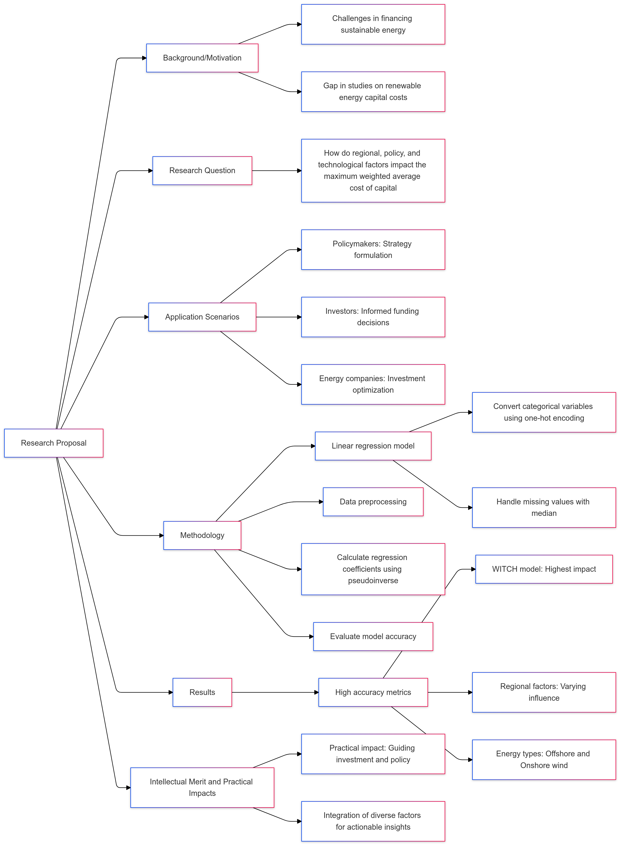

**Background/Motivation**

The energy sector faces significant challenges in financing transitions toward sustainable and renewable energy sources, with capital costs representing a key barrier. Previous studies have identified weighted average cost of capital (WACC) as a critical factor impacting energy investment viability, particularly in regions with unstable economic or policy frameworks. Despite substantial research on capital costs in traditional energy markets, limited studies focus on renewable energy scenarios across diverse regions and policy frameworks. This research addresses this gap by analyzing an open-source dataset that includes capital cost data across multiple energy models, regions, and policy scenarios. Understanding how various factors influence WACC can help identify strategies for reducing capital costs, thereby promoting renewable energy adoption and aiding global sustainability efforts. This study is motivated by the pressing need for insights into financial mechanisms that can drive sustainable energy investment at scale.

**Research Question**

How do regional, policy, and technological factors impact the maximum weighted average cost of capital (maxwacc) in renewable energy investment scenarios?

**Application Scenarios**

This research has valuable applications across multiple sectors. Policymakers can use the findings to formulate strategies that reduce financing costs for renewable energy, fostering investment and sustainability goals. Investors and financial institutions could leverage these insights to make informed decisions on energy project funding, prioritizing areas and scenarios with lower financial risk. Furthermore, energy companies could apply the findings to optimize investment strategies by focusing on regions and policy frameworks conducive to lower capital costs, ultimately accelerating the transition to renewable energy sources.

**Methodology**

This study employs a linear regression model to analyze the impact of various factors on the maximum weighted average cost of capital (WACC) in renewable energy investment scenarios. The dataset, which includes regional, policy, and energy-type information, is preprocessed by converting categorical variables such as Region, Scenario, Variable, and semigroup into dummy variables through one-hot encoding. This approach ensures that all data is in numerical form, suitable for regression analysis. Missing values in the dataset are filled with the median to maintain consistency and minimize data loss.

The model uses the pseudoinverse method to calculate regression coefficients, a stable approach even with potential multicollinearity. The regression coefficients reveal the relative impact of each feature on maxwacc, where positive values indicate factors that increase capital costs, while negative values represent cost-reducing influences. The model's accuracy is evaluated using Mean Squared Error (MSE) and R-squared (R²) metrics.

**Results**

The linear regression model achieved a high degree of accuracy, with a Mean Squared Error (MSE) of 7.54×10−67.54×10−6 and an R-squared (R²) value of 0.9608, indicating that approximately 96% of the variance in maxwacc is explained by the selected features. This performance suggests that the chosen factors—such as region, energy type, and scenario grouping—are highly relevant to predicting capital costs in the renewable energy sector.

The feature impact analysis reveals key insights. The WITCH model has the highest positive coefficient (0.6646), suggesting a significant impact on increasing maxwacc, followed by IMACLIM (0.2183) and IMAGE (0.1465). Regional factors, such as Region Middle East (0.0009) and Region Latin America (0.0004), exhibit smaller but positive influences on capital costs, whereas regions like Pacific OECD (-0.0013) show a minor cost-reducing effect. In terms of energy types, offshore (0.0046) and Onshore (0.0019) wind energy contribute to higher capital costs, while other types like Nuclear (0.0001) and Hydro (0.0003) have a marginal effect.

Overall, the results highlight that specific regional and technological factors play a significant role in determining capital costs. These insights could inform strategies to optimize investment and reduce financial risks, particularly in regions or energy types where high WACC values are identified. This analysis provides valuable data-driven guidance for policymakers, investors, and energy companies aiming to enhance the financial viability of renewable energy projects.

**Intellectual Merit and Practical Impacts**

This research contributes intellectually by enhancing our understanding of capital cost determinants in renewable energy investment, addressing a gap in existing studies focused on traditional energy sectors. By leveraging an open-source dataset and employing a robust regression methodology, this study advances the use of data-driven analysis in understanding financial barriers to sustainable energy. Practically, the findings could guide investment decisions and policy interventions aimed at reducing WACC, thereby accelerating renewable energy projects in high-impact regions. This study innovates by integrating diverse policy, regional, and technological factors into a single analytical framework, offering actionable insights that can inform strategies for a global energy transition.

**References**

Calcaterra, M., Reis, L. A., P. Fragkos, T. Briera, de, S., Egli, F., Emmerling, J., Iyer, G., Mittal, S., Polzin, J., Sanders, L., Schmidt, T. S., A. Serebriakova, Steffen, B., van, Vuuren, van, Waidelich, P., & M. Tavoni. (2024). Reducing the cost of capital to finance the energy transition in developing countries. *Nature Energy*. https://doi.org/10.1038/s41560-024-01606-7

**EXERCISE 3**

Source：

Artificial intelligence in science: An emerging general method of invention。

<https://www.nature.com/articles/d41586-019-02073-3>

**Reflection:**

This article highlights AI's transformative role in drug discovery, enhancing speed and precision. I'm inspired by AI's potential to accelerate breakthroughs in medicine, demonstrating how technology can unlock new pathways for understanding complex biological processes and ultimately improve patient outcomes.